MULLER PANDA 1
instruction guide

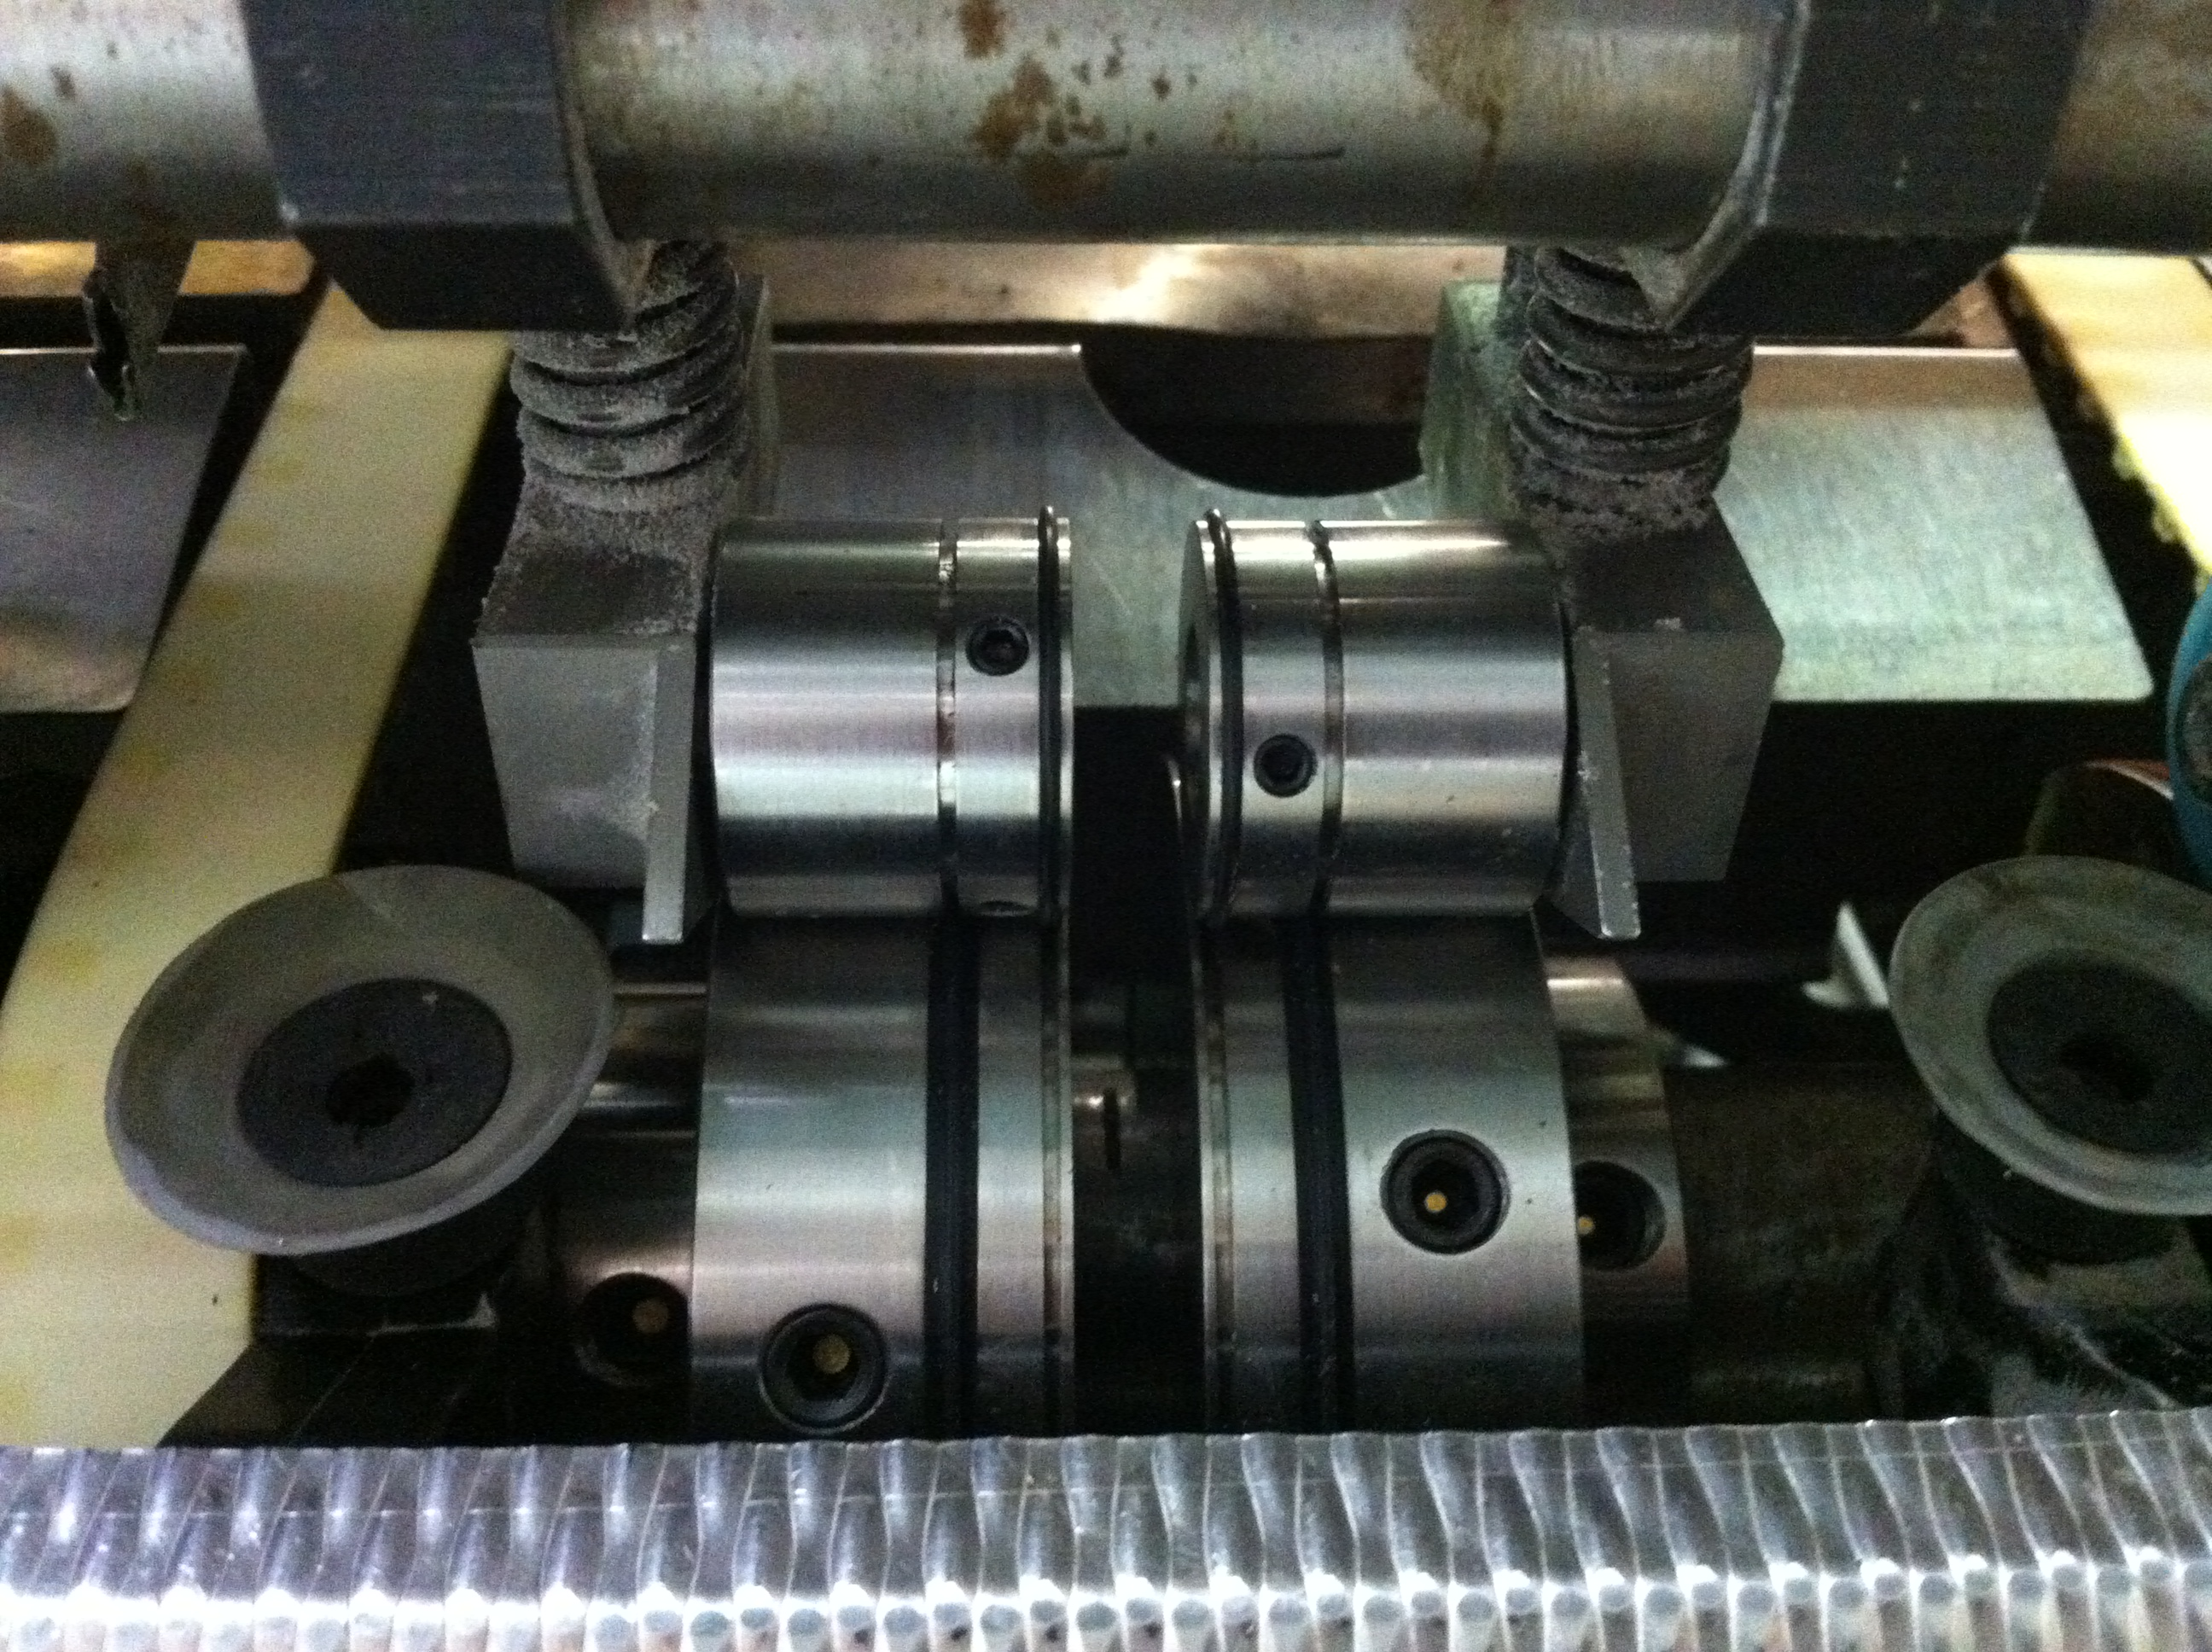
To obtain correct calliper pressure place the cover stock between the smooth metal parts and not under the crease ribs

Centralising the creasing rib and female channel

When installing the Bottom creasing unit it is important to align the bottom creasing unit inline with the edge of the spine clamp. Once it has been correctly aligned it should never have to be moved again.

When setting the top creasing unit it is important to guide the creasing rib into the bottom female creasing unit channel located directly below but do not tighten. Run a cover through the crease units. When the cover stock passes through the crease units the loose top crease units automatically centralise themselves into perfect alignment. Tighten the top creasing units while the cover stock is still being gripped.

